DAY 3
Mandati Sharan Mahi Reddy

Project: Online Grocery Delivery Application
Jira Project Key: OGD
Methodology: Agile – Scrum
Set 1 – Online Grocery Delivery Application
TASK 1 – PRODUCT VISION STATEMENT AND SCRUM ROLES
The product vision defines the goal of developing a convenient online grocery delivery application. The Scrum roles and their responsibilities were documented to establish clear ownership, collaboration and effective team coordination.

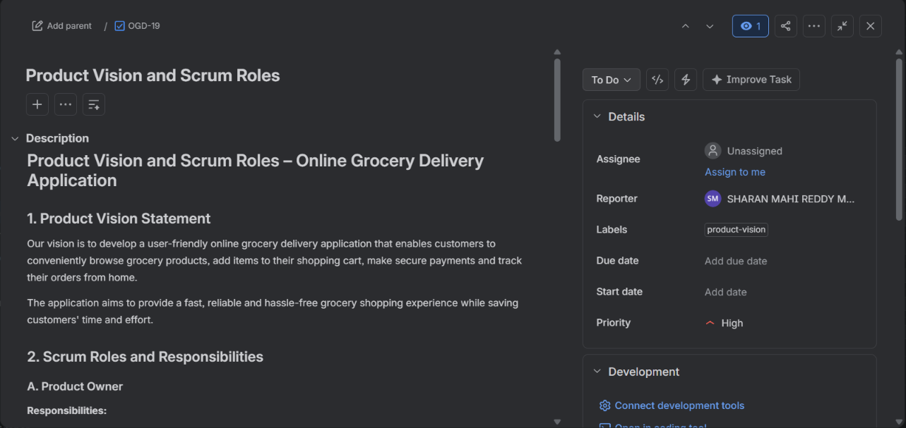
TASK 2 – CREATE EPICS AND USER STORIES
Three Epics were created in Jira: Browse and Search, Cart and Checkout, and Delivery Tracking. These Epics were divided into 12 User Stories using the As a / I want / So that format to represent the application's main functionalities.

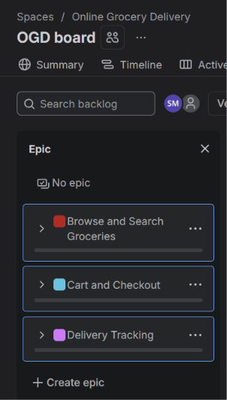
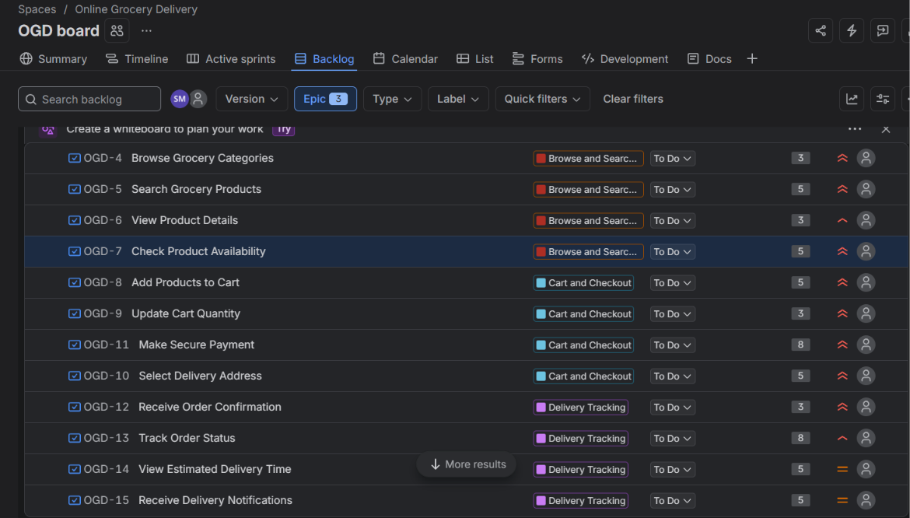
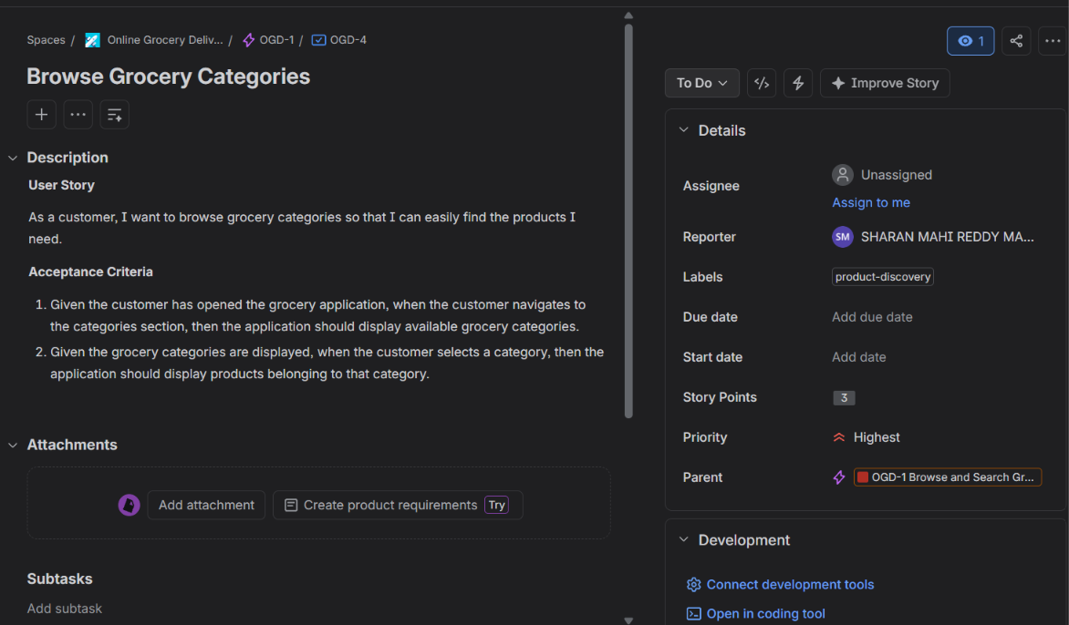

TASK 3 – APPLY THE INVEST CHECKLIST
All 12 User Stories were reviewed using the INVEST principles: Independent, Negotiable, Valuable, Estimable, Small and Testable. Stories that required improvement were identified and rewritten to make their requirements clearer and easier to validate.

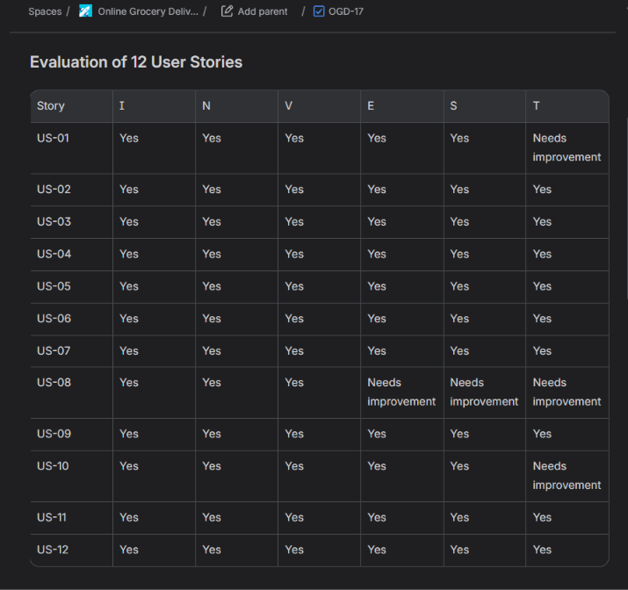
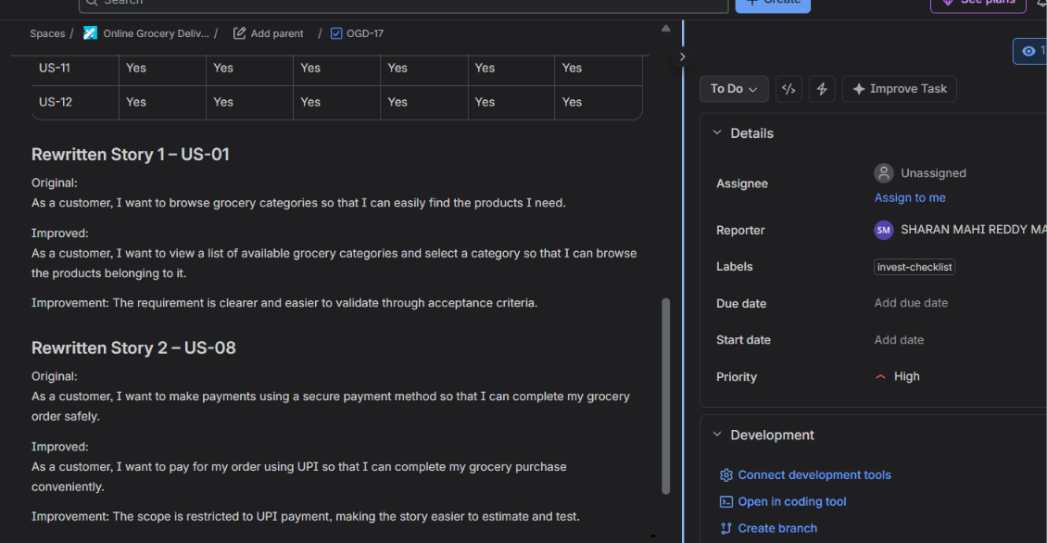

TASK 4 – ACCEPTANCE CRITERIA USING GIVEN / WHEN / THEN
Acceptance criteria were defined for the User Stories using the Given / When / Then format. Both successful scenarios and negative scenarios, such as searching for a product that does not exist, were considered to verify the expected application behaviour.

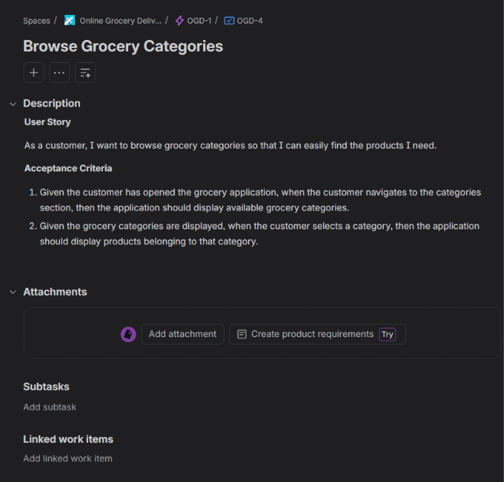
US-01 Acceptance Criteria in Jira
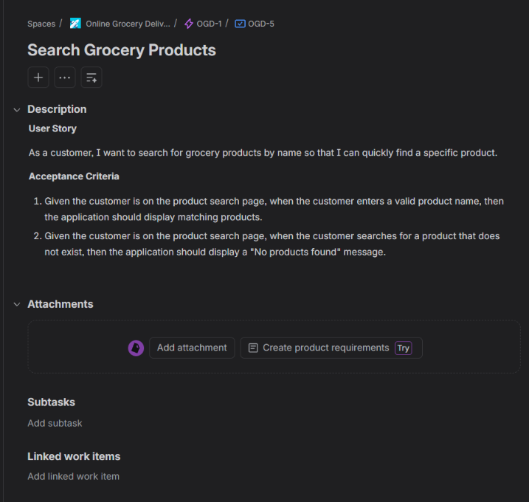
US-02 Acceptance Criteria with Negative Scenario
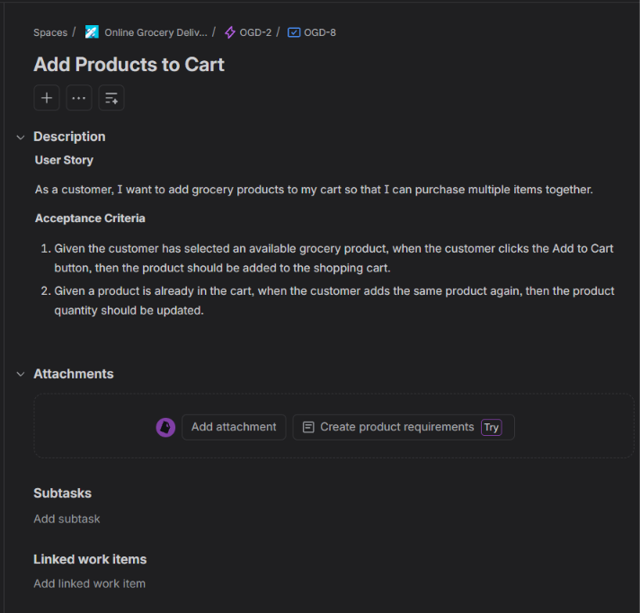
US-05 Acceptance Criteria in Jira
TASK 5 – MOSCOW PRIORITISATION AND FIBONACCI ESTIMATION
The User Stories were prioritised based on business importance using the MoSCoW technique. Fibonacci story points were assigned through Planning Poker, and the estimation discussion was documented to explain the team's final decisions.
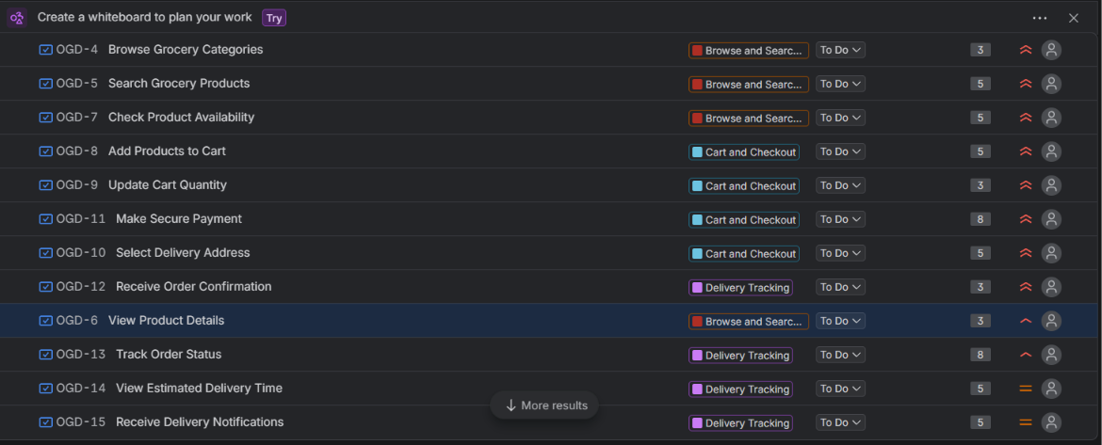
Jira Backlog Showing Priorities
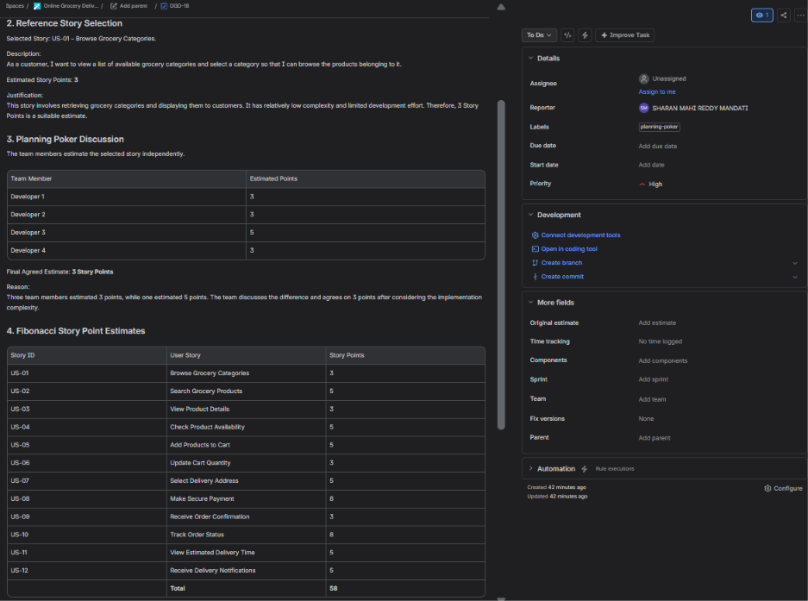
OGD-18: Planning Poker and Fibonacci Estimation
TASK 6 – PUBLISH EPICS AND STORIES ON JIRA BOARD
The Epics and User Stories were organised in the Jira backlog and assigned to Sprint 1. The Jira board displays the workflow states, while the Definition of Ready (DoR) and Definition of Done (DoD) were documented to establish clear completion criteria.

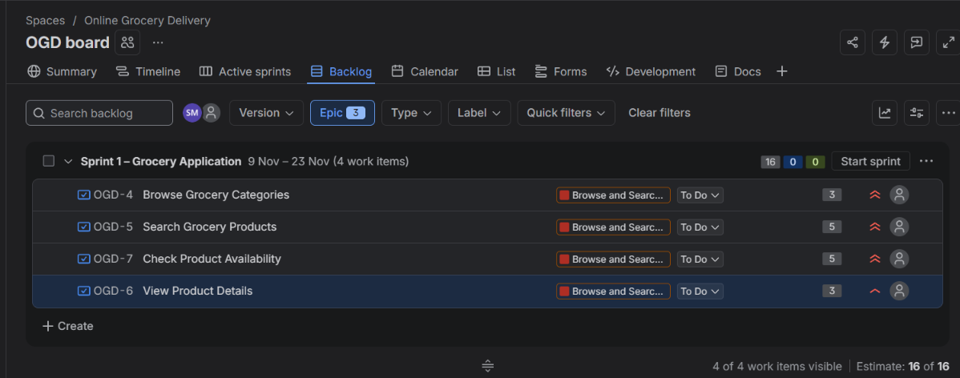
Jira Backlog Showing Sprint 1 and Four Stories
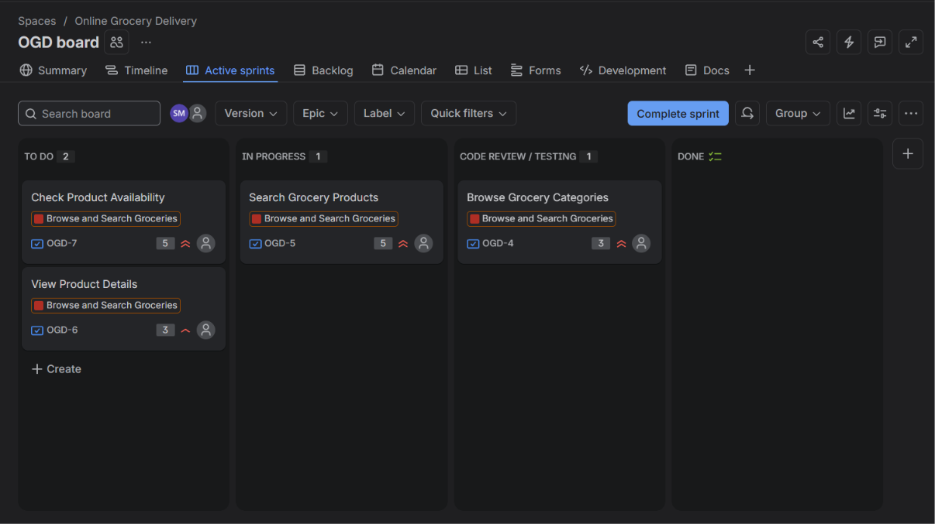
Jira Active Sprints Board Showing Workflow Columns
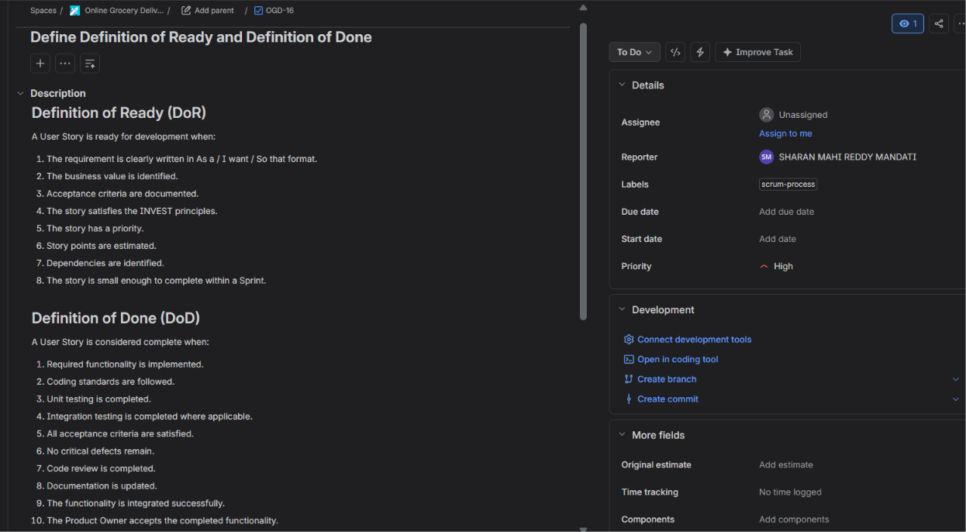
OGD-16: Definition of Ready and Definition of Done

SET 2 - Insurance Claims Portal
Task 1 – Product Vision and Waterfall vs Agile
1. Product Vision
To develop a user-friendly Insurance Claims Portal that enables customers to register insurance claims, upload supporting documents, track claim progress and receive settlement notifications. The portal aims to make the claim process faster, transparent, secure and convenient for customers.
2. Waterfall vs Agile Comparison
Waterfall Model | Agile Model
Follows a sequential development approach. | Follows an iterative and incremental approach.
Requirements are defined at the beginning. | Requirements can evolve based on feedback.
Testing is generally performed after development. | Testing is performed continuously.
Changes are difficult and costly to implement. | Changes can be accommodated more easily.
Customer feedback is limited during development. | Customer feedback is collected regularly.
3. Why Agile is Suitable
Agile is suitable for the Insurance Claims Portal because requirements may change based on customer feedback and insurance business needs. Features such as claim registration, document uploading, claim tracking and notifications can be developed and delivered incrementally. Regular testing and feedback help identify issues early and improve product quality. Therefore, Agile provides flexibility, faster delivery and better customer satisfaction.

Task 2 – Create Epics and User Stories
Four Epics were created in Jira: Claim Registration, Document Upload, Claim Tracking and Settlement Notifications. A total of 12 User Stories were initially created and organised under their respective Epics to cover the major portal functionalities.

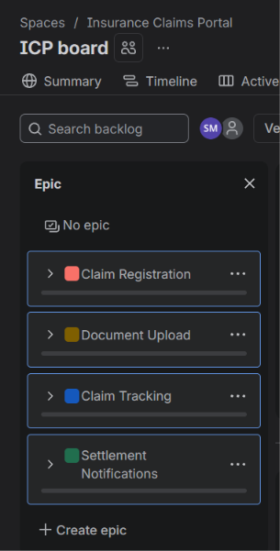
All four Epics in the Jira Epic panel
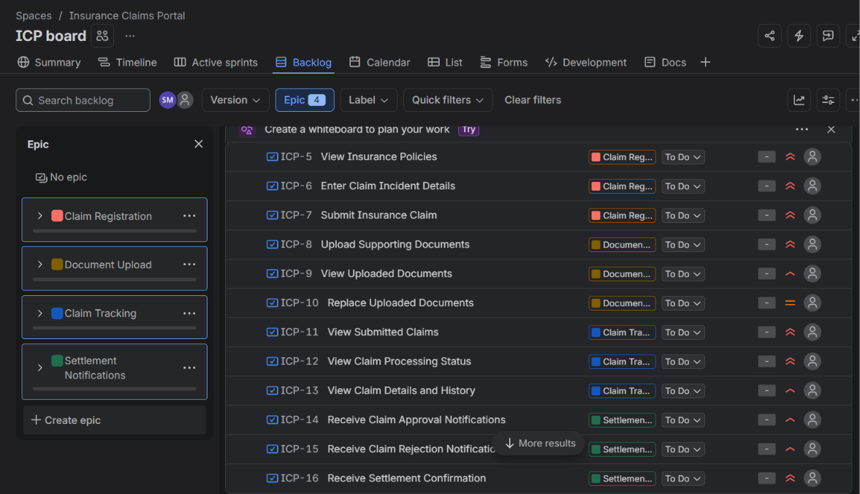
Original 12 User Stories under their respective Epics

Task 3 – INVEST Review and Vertical Story Splitting
The User Stories were reviewed using the INVEST principles to identify oversized requirements. The original Submit Insurance Claim story (ICP-7) was split into two independent, customer-focused stories: Review Claim Application and Submit Insurance Claim.
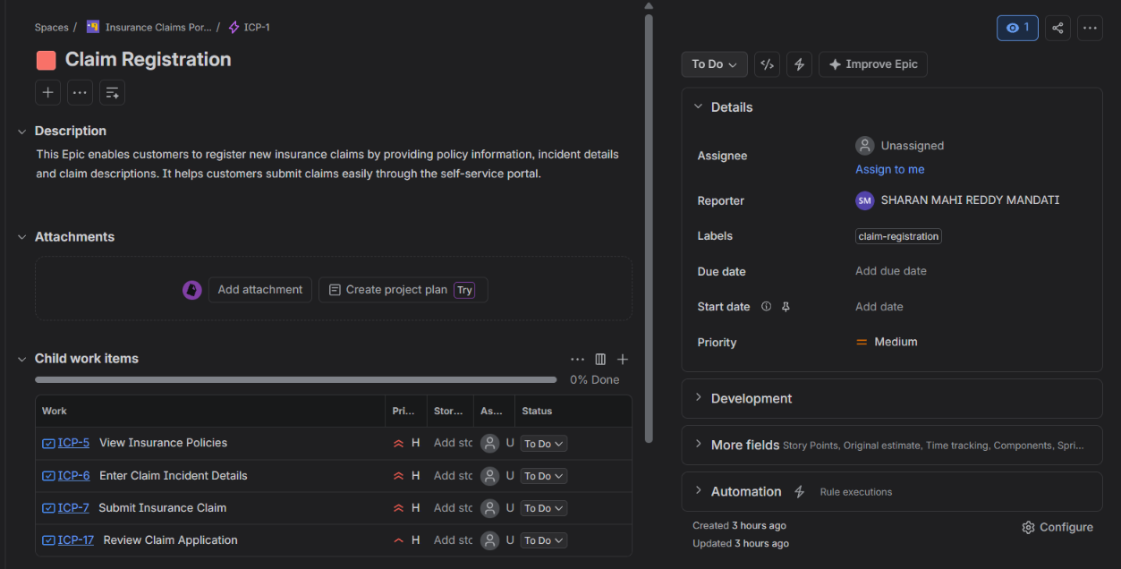
Vertical Story Splitting: Jira showing the original ICP-7 and the two resulting Stories.
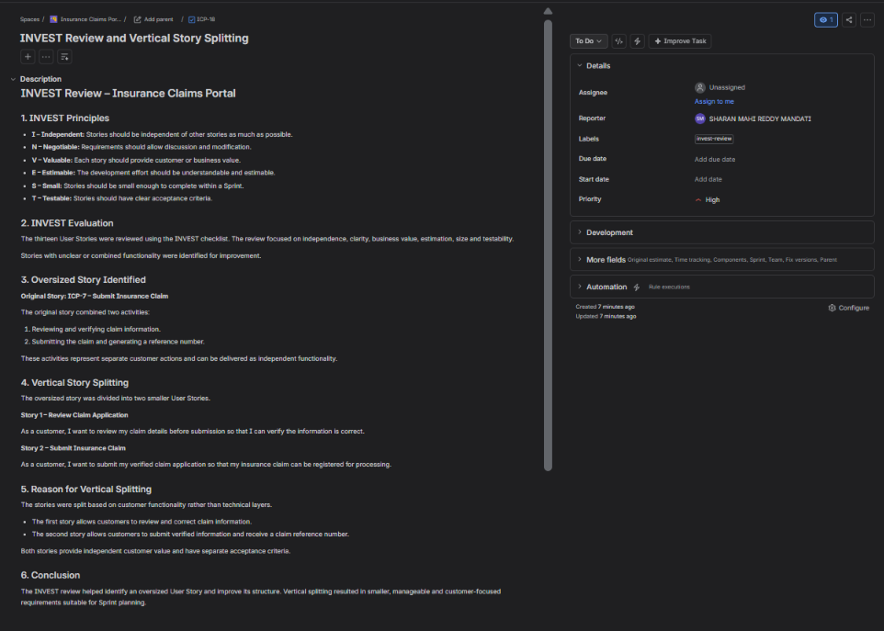
INVEST Review: Jira Task showing the INVEST principles and evaluation.

Task 4 – Acceptance Criteria Using Given / When / Then
Given / When / Then acceptance criteria were added to the Claim Registration stories. Positive scenarios and validation failures were included to ensure that customers can submit complete and valid claim information.

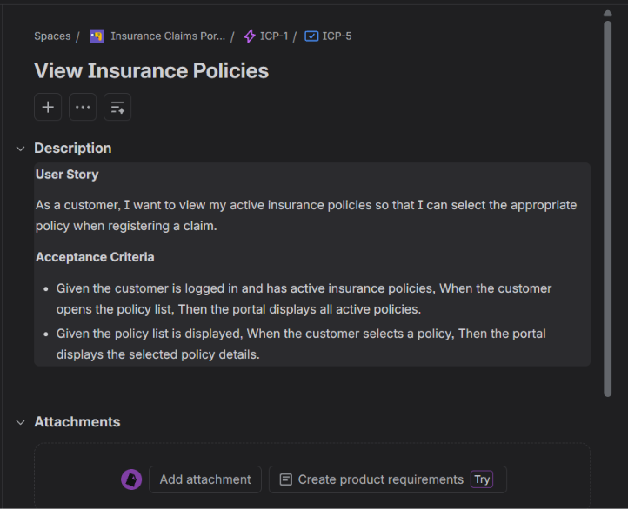
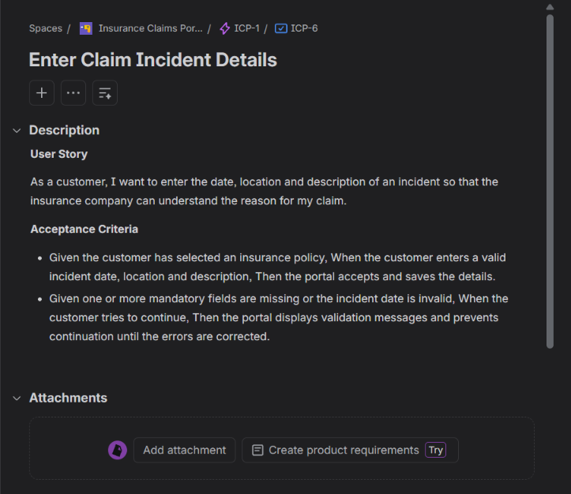
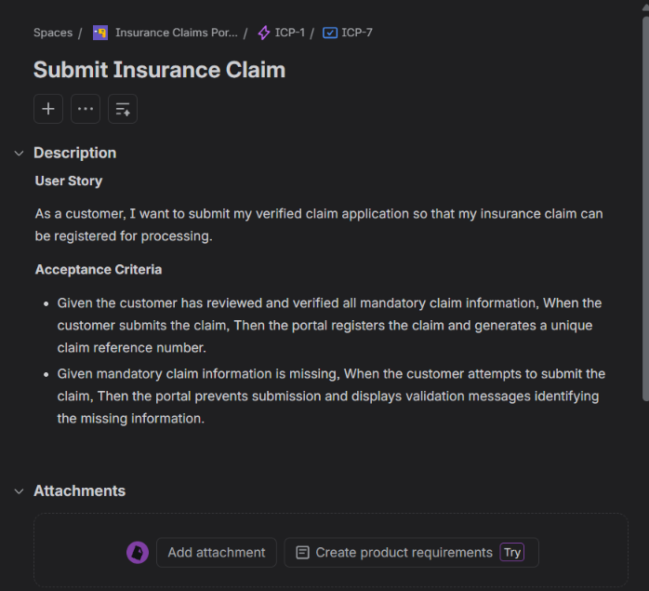
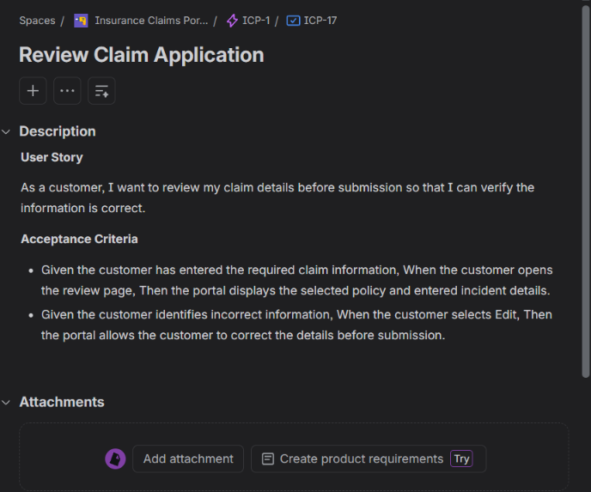
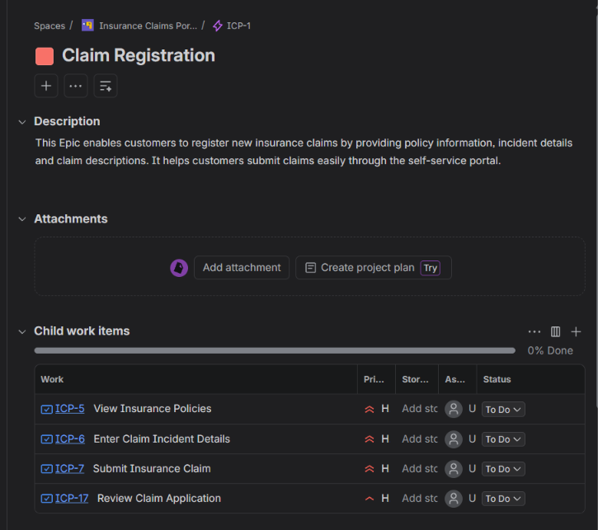

Task 5 – Fibonacci Estimation and Planning Poker
All 13 User Stories were estimated using Fibonacci values (1, 2, 3, 5, 8 and 13). Planning Poker was used to discuss different estimates, identify an outlier for the Upload Supporting Documents story and agree on a final estimate. The total backlog estimate was calculated as 56 Story Points.

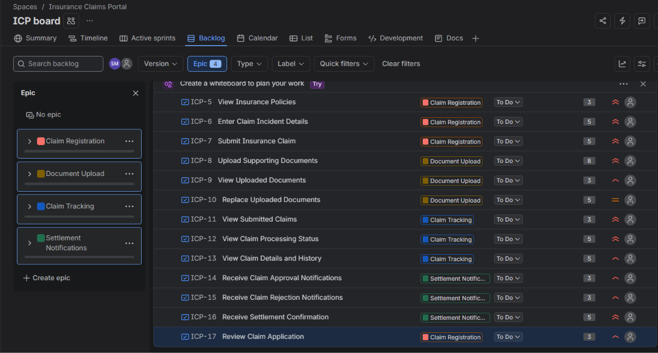
Fibonacci Numbers For Each Story

Planning Poker Estimation – ICP-8: Upload Supporting Documents
Team Member | Estimated Story Points | Discussion
Developer 1 | 5 | Considered it a moderately complex task.
Developer 2 | 8 | Considered file validation and upload requirements.
Developer 3 | 13 | Outlier estimate due to possible upload complexity.
Developer 4 | 8 | Agreed with the complexity of the requirements.
Final Team Estimate | 8 | Agreed after discussion.

Outlier Identification and Resolution
Developer 3 estimated 13 story points, which was higher than the other estimates. The reason was the possible complexity of file-size restrictions, file-format validation and document uploading.
The team discussed these concerns and reviewed the actual requirements. After discussion, all members agreed on 8 Story Points as the final estimate.
Conclusion: Planning Poker helped the team discuss different opinions, resolve estimation differences and reach a common estimate.

Backlog Estimation Summary
Epic | Story Points
Claim Registration | 16
Document Upload | 16
Claim Tracking | 13
Settlement Notifications | 11
Total | 56

Task 6:
The Jira board was configured with four workflow states: To Do, In Progress, In Review and Done. The Definition of Done was documented with quality, testing, validation, code review and acceptance criteria to ensure that completed stories meet the expected standards.

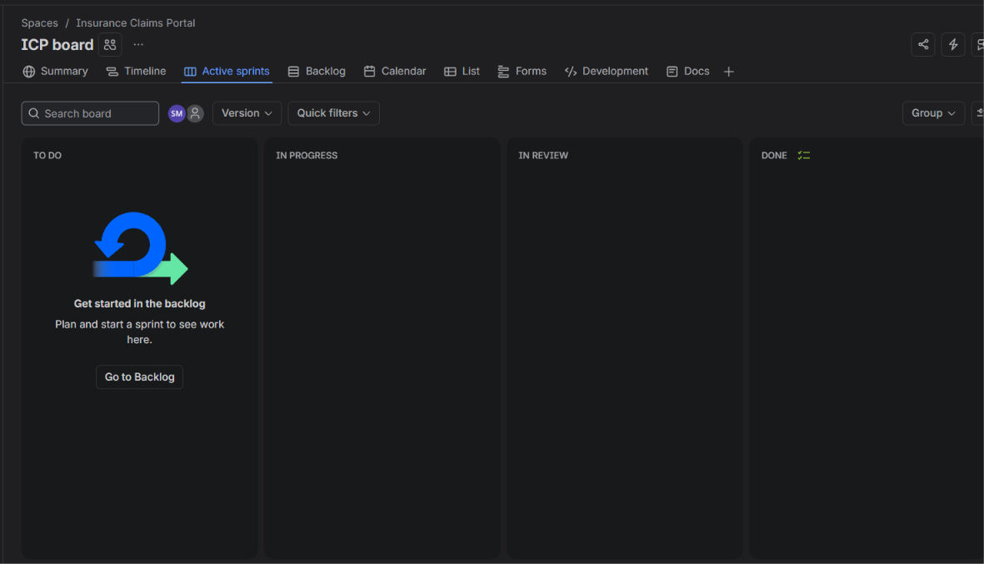
Insurance Claims Portal Jira board configured with To Do, In Progress, In Review and Done workflow states.

Definition of Done – Insurance Claims Portal
A User Story is considered Done when it satisfies the following conditions:
- All agreed requirements and acceptance criteria are completed.
- The functionality works as expected.
- All mandatory input validations are implemented.
- Unit and functional testing are completed successfully.
- No critical or major defects remain unresolved.
- Code is reviewed and follows coding standards.
- Changes are integrated successfully.
- Relevant technical documentation is updated.
- The Product Owner or authorised reviewer accepts the completed functionality.
Conclusion: These criteria ensure that every completed User Story meets the required quality standards and is ready for delivery.

SET 3 - Hospital Appointment Booking Application
Task 1 – Product Vision and Stakeholder Mapping
1. Product Vision Statement
To develop a user-friendly mobile application that allows patients to book, reschedule and cancel doctor appointments conveniently. The application will provide real-time doctor availability, appointment reminders and efficient schedule management to reduce waiting time and improve the overall patient experience.
2. Identify the Stakeholders
The main stakeholders are:
- Patients: Book, reschedule and cancel appointments.
- Doctors: View appointments and manage availability.
- Receptionists: Assist patients and manage appointment schedules.
- Hospital Management: Monitor appointment operations and service quality.
- Hospital IT Team: Maintain application security and technical operations.
- Notification Service Provider: Deliver appointment reminders.
3. Map Stakeholders to Scrum Roles
Stakeholder | Scrum Role | Responsibility
Hospital Management | Product Owner | Defines business goals and prioritises backlog.
Hospital IT Project Coordinator | Scrum Master | Facilitates Scrum activities and removes blockers.
Developers | Developer | Design, develop and test the application.
Patients | Customer | Use the application and provide feedback.
Doctors | Customer | Use appointment schedules and provide requirements.
Receptionists | Customer | Support appointment booking and schedule management.

Task 2 – Create Epics and User Stories
Four Epics were created in Jira: Appointment Booking, Rescheduling and Cancellation, Appointment Reminders and Doctor Schedule Management. These Epics were divided into 12 User Stories to cover the main requirements of patients and doctors.

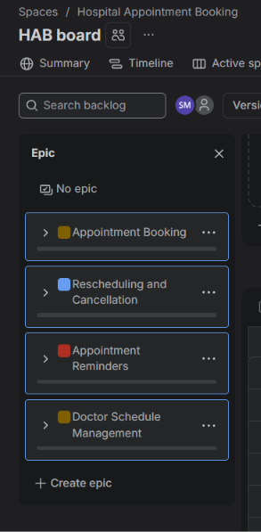
ALL 4 EPICS

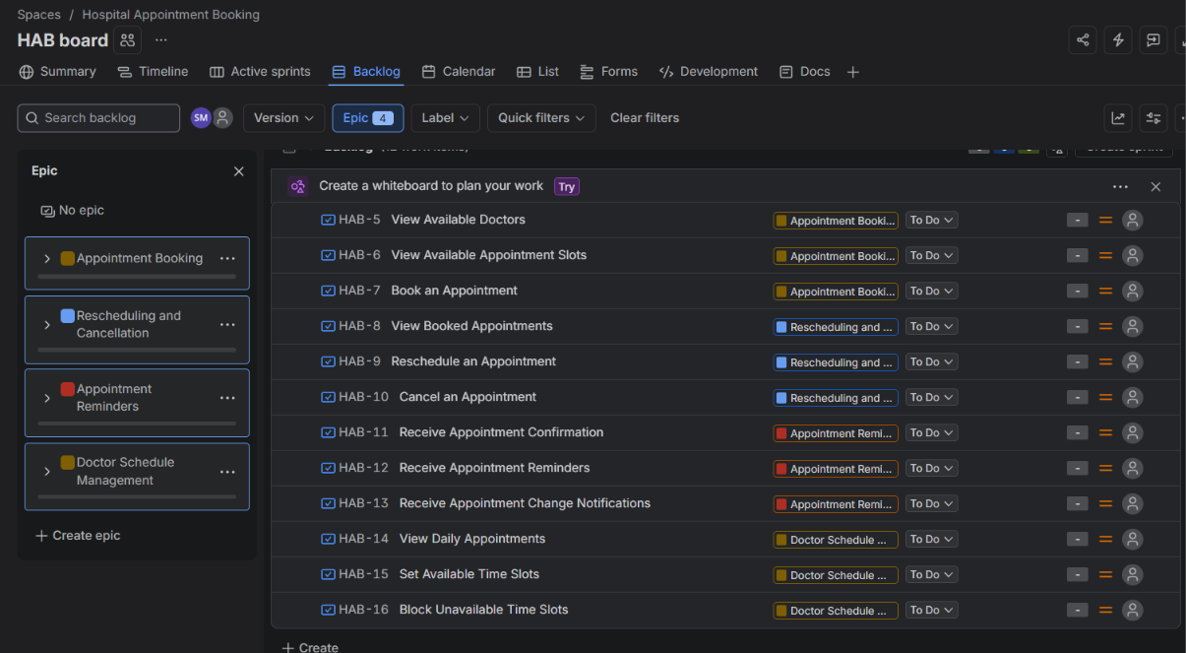
ALL 12 USER STORIES

TASK 3 – INVEST Evaluation and Story Improvement
All 12 User Stories were reviewed against the INVEST principles. Eight stories were refined to improve requirement clarity, independence, estimability and testability, making them more suitable for development and Sprint planning.

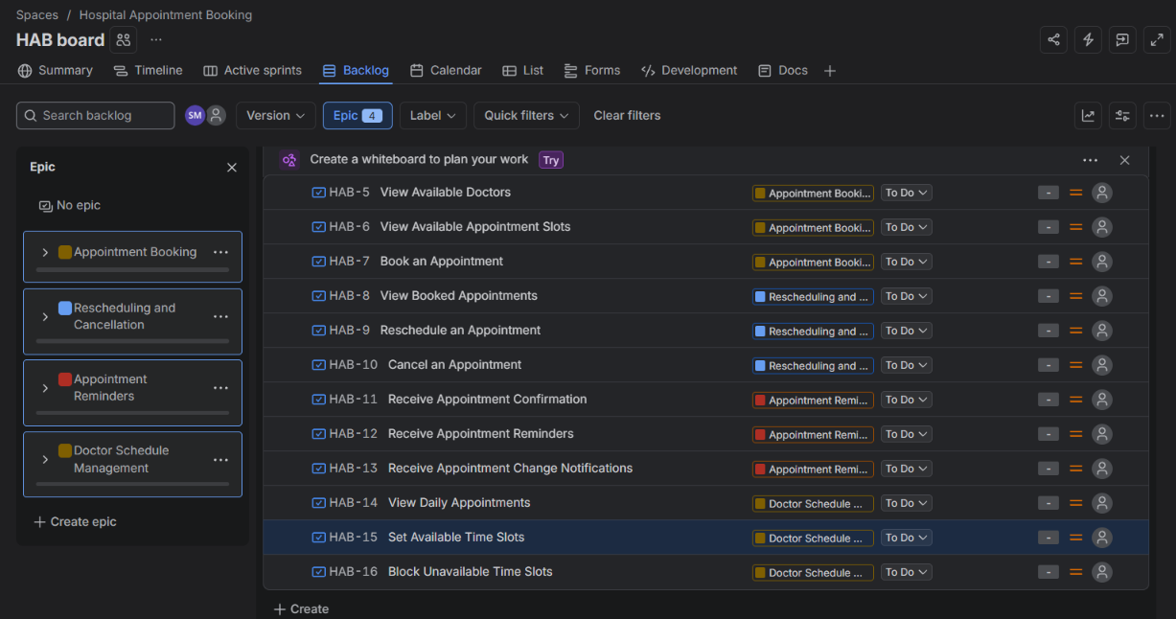

US-01 – View Available Doctors
As a patient, I want to view doctors by their speciality so that I can select a doctor who can treat my medical condition.
US-02 – View Available Appointment Slots
As a patient, I want to view the available appointment slots for a selected doctor and date so that I can choose a suitable appointment time.
US-03 – Book an Appointment
As a patient, I want to confirm an available appointment slot with my selected doctor so that my appointment is successfully booked.
US-05 – Reschedule an Appointment
As a patient, I want to select a new available time slot for my existing appointment so that I can change my appointment schedule.
US-07 – Receive Appointment Confirmation
As a patient, I want to receive a confirmation notification after successfully booking an appointment so that I have proof of my booking.
US-08 – Receive Appointment Reminders
As a patient, I want to receive a reminder notification 24 hours before my scheduled appointment so that I remember my consultation.
US-09 – Receive Appointment Change Notifications
As a patient, I want to receive a notification whenever my appointment is rescheduled or cancelled so that I am informed about changes to my booking.
US-11 – Set Available Time Slots
As a doctor, I want to define my available appointment dates and time slots so that patients can book appointments during my working hours.

Conclusion – INVEST Evaluation
All 12 User Stories were reviewed using the INVEST principles. Eight stories were refined to improve independence, clarity and testability. The updated stories provide clear customer value and make requirements easier to estimate, implement and validate.

Task 4 – Acceptance Criteria Using Given / When / Then
Acceptance criteria were defined for the appointment booking stories using Given / When / Then scenarios. The criteria cover doctor selection, appointment slot availability and successful booking, including the negative scenario where the selected slot has already been taken.

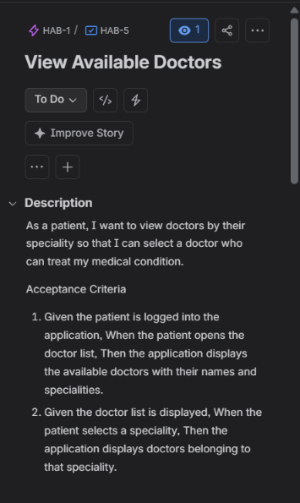
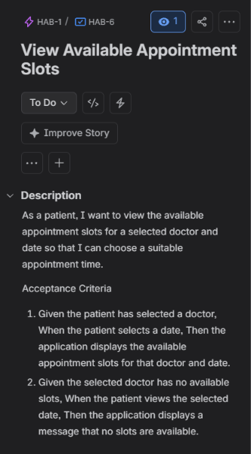
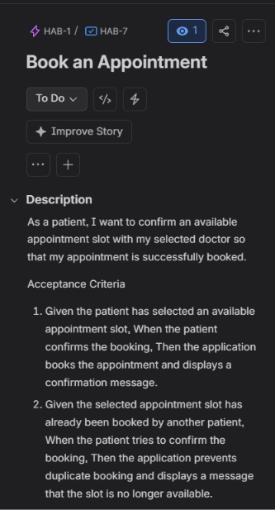

Task 5 – Business Value Prioritisation and Estimation
The User Stories were prioritised using the MoSCoW technique based on business value. Fibonacci Story Points were assigned through Planning Poker, including discussion of an outlier estimate for Book an Appointment. The total estimated backlog size was 46 Story Points. The difference between Story Points and actual working hours was also explained.

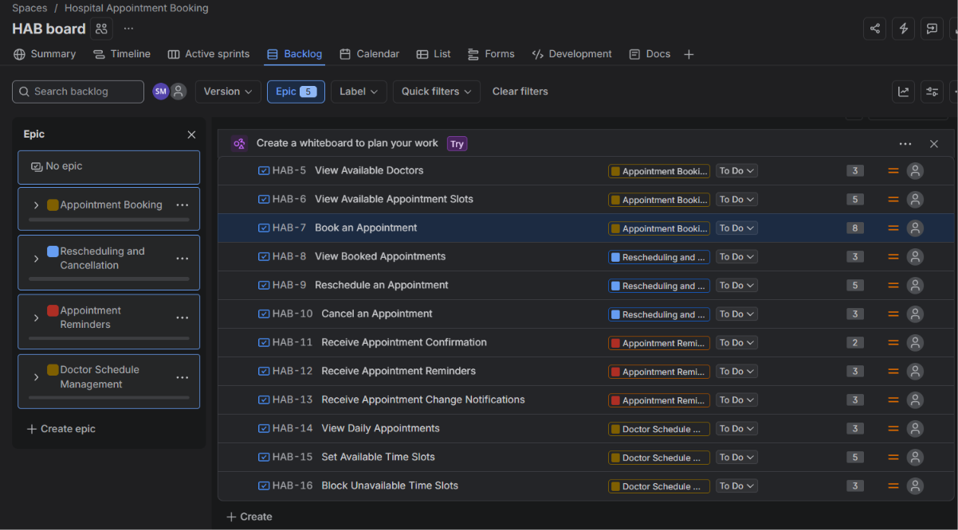

Planning Poker Discussion
Use US-03 – Book an Appointment as the example.
Team Member | Estimate
Developer 1 | 5
Developer 2 | 8
Developer 3 | 13
Developer 4 | 8
Final agreed estimate | 8
Outlier identification: Developer 3 estimated 13 points because of concerns about appointment-slot conflicts, duplicate bookings and booking validation.
Team discussion: The team discussed the complexity and agreed that the story could be completed within the current scope. The final estimate was agreed as 8 Story Points.

Difference Between Story Points and Hours
Story Points | Hours
Measure relative effort and complexity. | Measure actual time spent.
Consider complexity, risk and effort. | Represent time taken to complete work.
Estimated by the team. | Recorded based on actual work.
Do not represent fixed hours. | Expressed in hours or days.
Example: A Story estimated at 5 points does not automatically mean 5 hours. It represents the team's relative assessment of its complexity and effort.
Business Value Prioritisation and Estimation
The 12 User Stories were prioritised using the MoSCoW technique based on their business value. Essential appointment booking and schedule management features were classified as Must Have, while additional convenience features were classified as Should Have.
The team used Fibonacci numbers to estimate the relative effort and complexity of each User Story. Planning Poker was used to discuss different estimates and resolve disagreements. For US-03, the team agreed on 8 Story Points after discussing the higher estimate of 13.
The total estimated backlog is 46 Story Points.
Story Points represent relative effort and complexity, whereas hours represent actual time spent. Therefore, Story Points should not be treated as fixed working hours.

Task 6 – Jira Backlog, Definition of Ready and Definition of Done
The 12 User Stories were organised under the four Epics in the Jira backlog and displayed on the Scrum board. The Definition of Ready (DoR) and Definition of Done (DoD) checklists were documented with eight and nine criteria respectively to establish clear standards before development and upon completion.

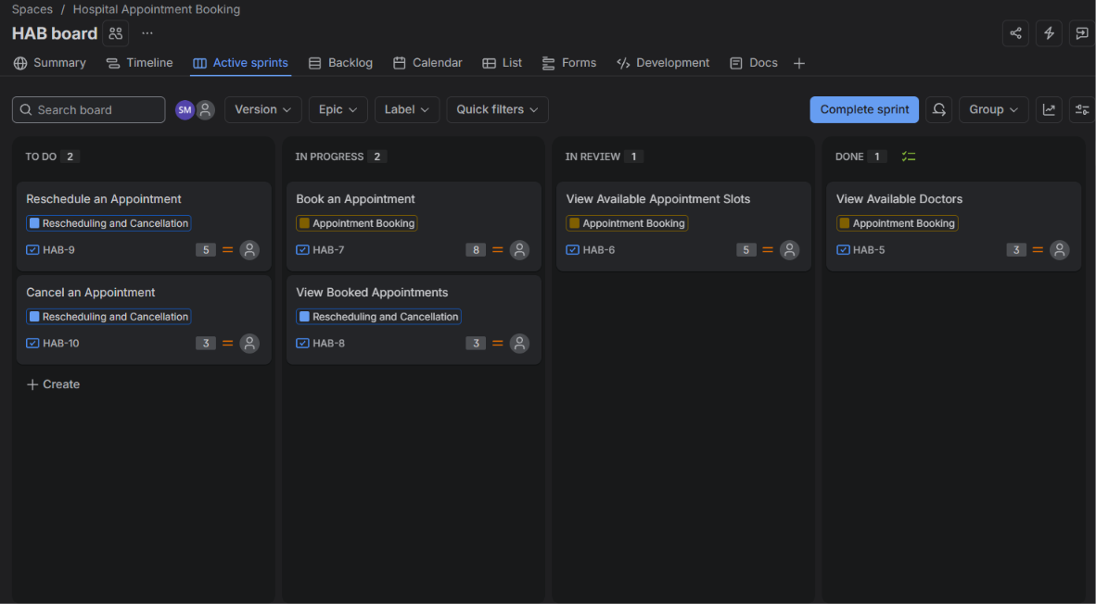

Definition of Ready (DoR) – Hospital Appointment Booking
A User Story is considered Ready for Sprint development when it satisfies the following conditions:
- The User Story is clearly written in As a / I want / So that format.
- Business value and priority are identified.
- Acceptance criteria are clearly defined.
- The story follows the INVEST principles.
- Dependencies and assumptions are identified.
- The story is small enough to complete within a Sprint.
- Required designs or supporting information are available.
- The story has been estimated by the development team.
Conclusion: DoR ensures that User Stories are sufficiently clear and prepared before entering a Sprint.

Definition of Done (DoD) – Hospital Appointment Booking
A User Story is considered Done when it satisfies the following conditions:
- All agreed requirements are implemented.
- All acceptance criteria are successfully satisfied.
- Appointment booking and validation work correctly.
- Unit and functional testing are completed successfully.
- No critical or major defects remain unresolved.
- Code review is completed and coding standards are followed.
- Changes are integrated successfully.
- Relevant documentation is updated.
- The Product Owner or authorised reviewer accepts the completed functionality.
Conclusion: DoD ensures that every completed User Story meets the required quality standards and is ready for delivery.

